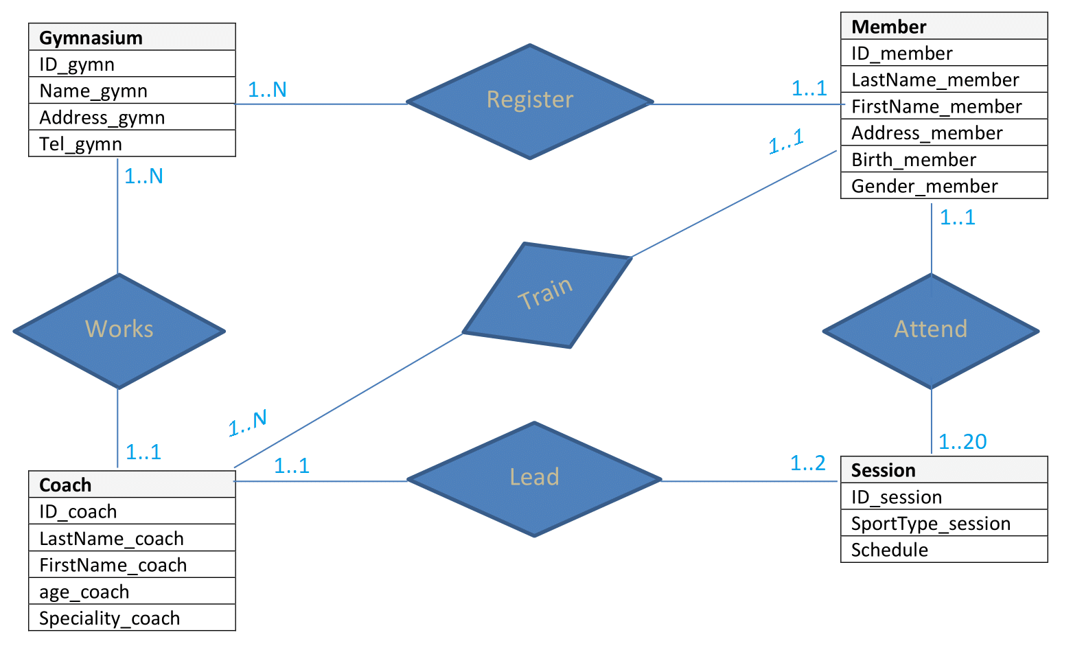

Relationships :
- A member can join 1 to 1 gymnasium, a gymnasium can have 1 to N members.
- A session can handle 1 to 20 members, a member can attend 1 to 1 sessions.
- A coach can lead 1 to 1 session, a session can be led by 1 to 2 sessions.

- A coach can work for 1 to 1 gymnasium, a gymnasium can have 1 to N coaches.
- A member can be trained by 1 to 1 coach, a coach can train 1 to N members.

https://github.com/MarinosTBH/Chapter_27_Checkpoint_Entity-relationship_model_06-06-22.git

